Digital Art
For one of the media sectors I have chosen to use for this assignment is GTA 5. One of the first things we notice about this logo is the white inside in the GTA part and we also notice the black outline and this occurs with most of the GTA logo’s.
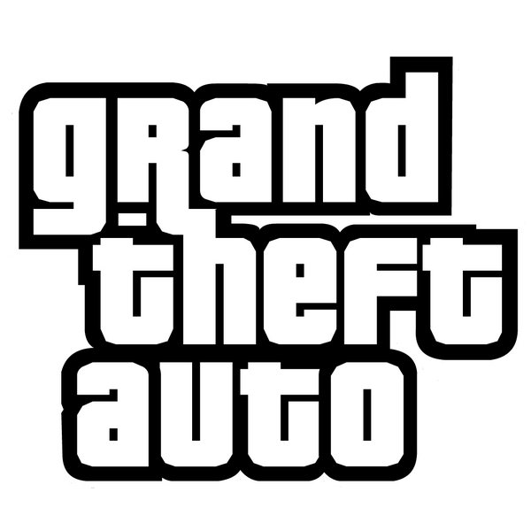
This is effective because by keeping the normal GTA bit you will recognise the logo on newer games (Like the new fifth one) or if you have played the newer games you will recognise it in the past games. The colour in this bit of the logo is effective because its bland black and white, so it’s not to eye catching, but eye catching enough for it to be memorable.

The second thing about the GTA 5 logo is the raised font for the Roman numeral five (V).

This is effective because it makes the title stand out and look more visually impressive because with the raised font it makes the number of the game stand out more, so we know which GTA were playing. It also adds a nice style to the game as well, but if we are going to talk about style we have to talk about the whole GTA V font as a whole.
Now, this part of the logo has a lot going on. The colours fade from light grey to a dark green and that could be to do with the game getting darker as you progress through it. Another thing we notice is that the shape of the V changes from bigger to smaller. This is effective with the change in colours going from lighter to darker because now we have it going from bigger to smaller.

We also have more raised font in the bit where it says FIVE. This could show the different levels of the font so it doesn’t just look like a boring 2D logo.

Another thing about the Five is how new it looks compared to the old GTA logo. It looks shiny next to the GTA part of the logo.

The last thing about this logo for GTA 5 is the font. The fonts for this are very different for the GTA and Five bit. The GTA bit looks rounded off and more 90’s old school font. Where as the five part looks more sharp and more dangerous, but as I said for the GTA part it’s in there for all of the games and doesn’t change at all, so it feels more home like when you’re playing the game. But with the Five part this could be the logo designer going this is going to be an adventure you’re not going to miss.

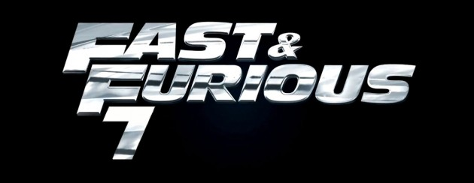
The other media sector I am using is film and I am using the Fast & Furious 7 logo. Unlike the GTA 5 logo this one is the same font and colour all the way through. The first thing that sticks out about this logo is how shiny it is. It’s like a car shining and to go with that shine is the risen font. It isn’t risen a lot, but enough to make a little difference.

The second thing that stands out is the colour. The colour is a very car silver chrome colour, so stands out with the shiny car theme going on and makes it look eye catching and makes people want to look at this logo if it’s on a poster. The third thing that stands out is the font. The font is very sharp and gives the font a new layer of interest and might make people feel more interested in the movie this is advertising.

The last thing to say about this logo is how it’s quite boring, but interesting as well. You have the Shiny, Silver, Chrome colour, with the sharp font and the raised (a little) font, but apart from that there isn’t much else to talk about this logo.

Comparison
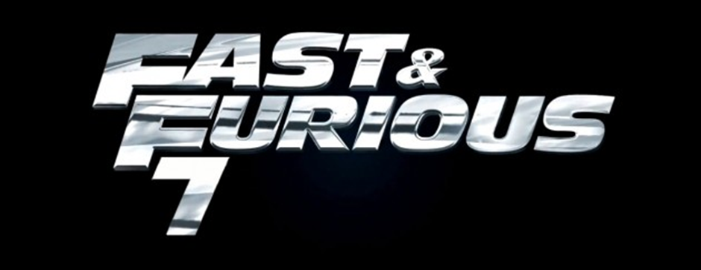
If we compare these two together we see that the Fast and Furious one looks a lot realer and you can see that it is designed to be put in a film because of the chrome look and the sharp edges and, the raised font. And if we look at the GTA logo we can see that it is designed for a game because it looks more cartoon like, but it also adds a fresh look to the old boring GTA logo part.

