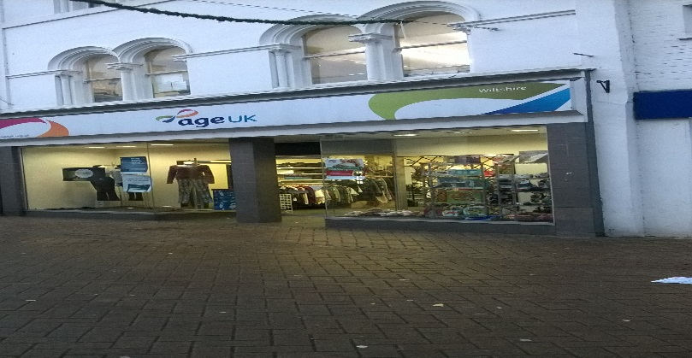 | 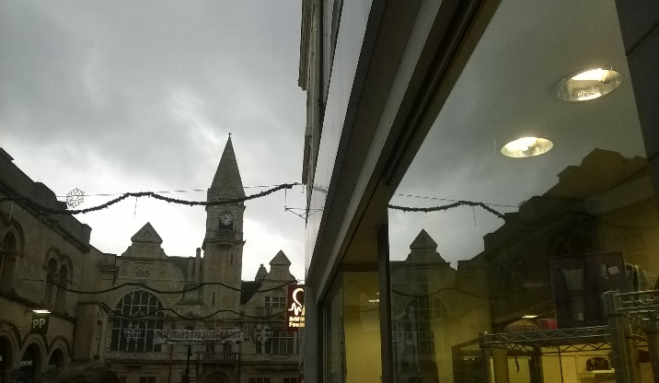
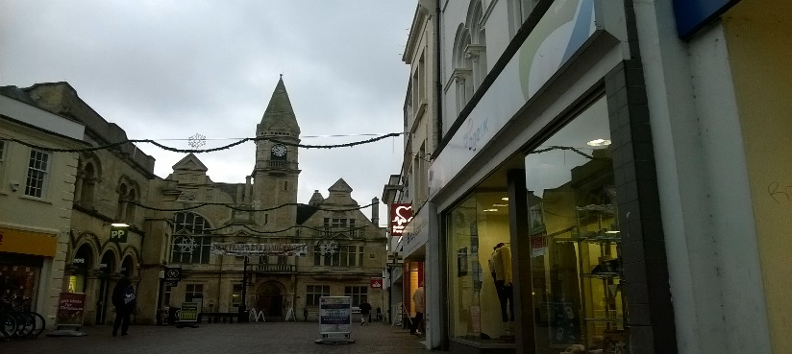 | 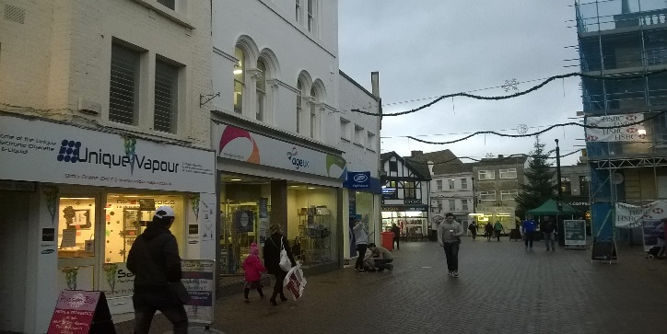
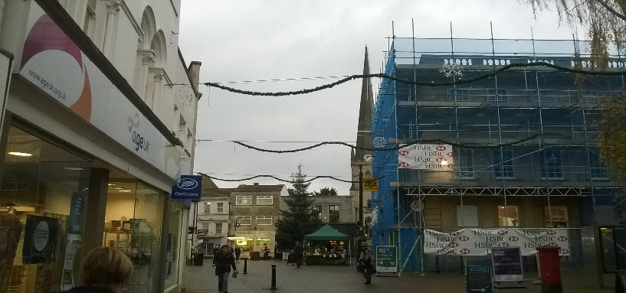 | 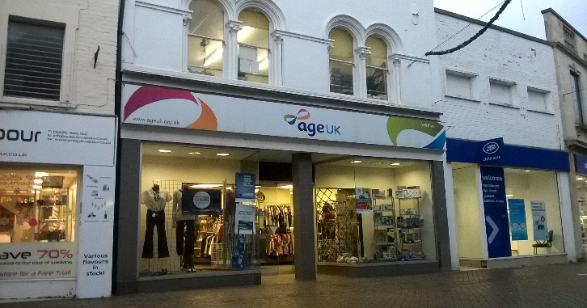
Justin – “I think that the location is good because it looks like a place where lots of people would walk by and where lots of people go this will help our film look real.”
Alanya – “This location is good for our advert as it is set in a town near Christmas where people will be walking around with shopping bags etc. As it is close to Christmas, there are lights around the area and when we film many people will be walking around with bags of shopping, therefore the town will look Christmassy which makes our idea look real.”
Lyle – “This part of Trowbridge is a good place to film because there are lots of Christmas decorations around and this would work with the theme of our advert. Also this shop is great for our shop window scene.”
Darius – “Yes because we have enough room to film. The store owner has given us permission to film there. There is really good natural lighting there. There is very limited sound interference when recording which is a good thing. We do have to consider filming around the public because certain people can get very defensive over people filming. It also suits our story board.”

