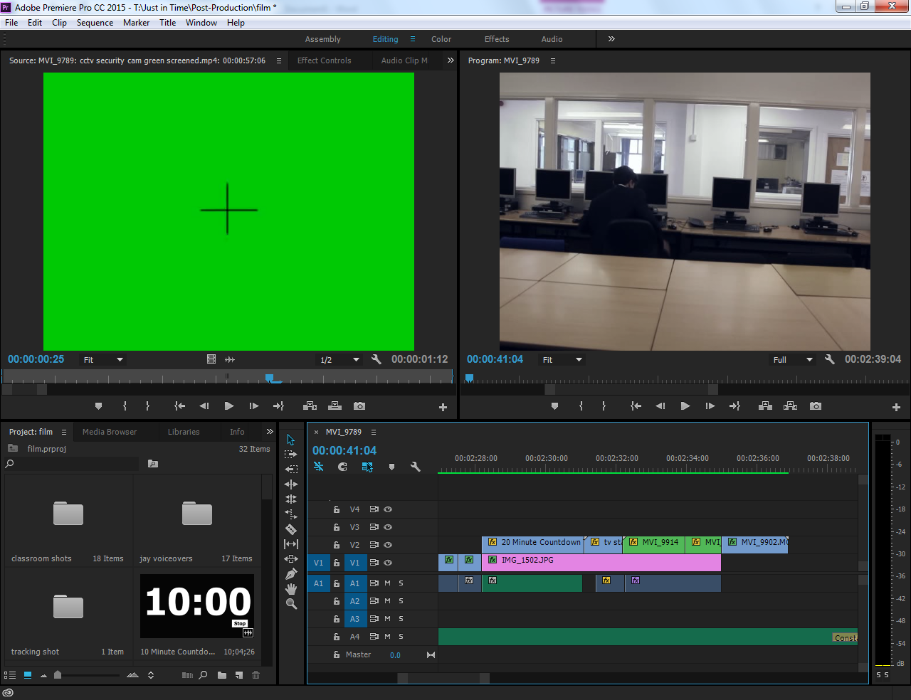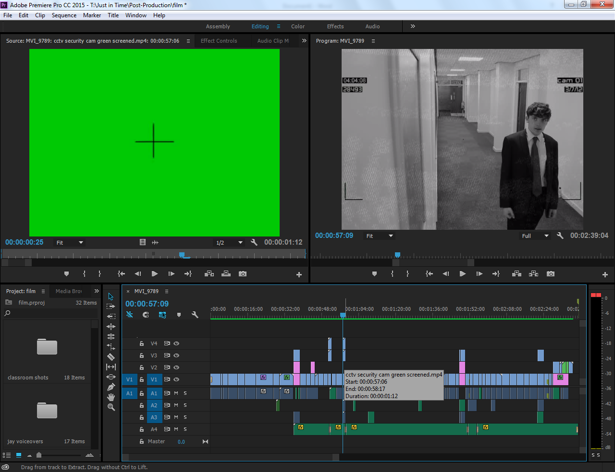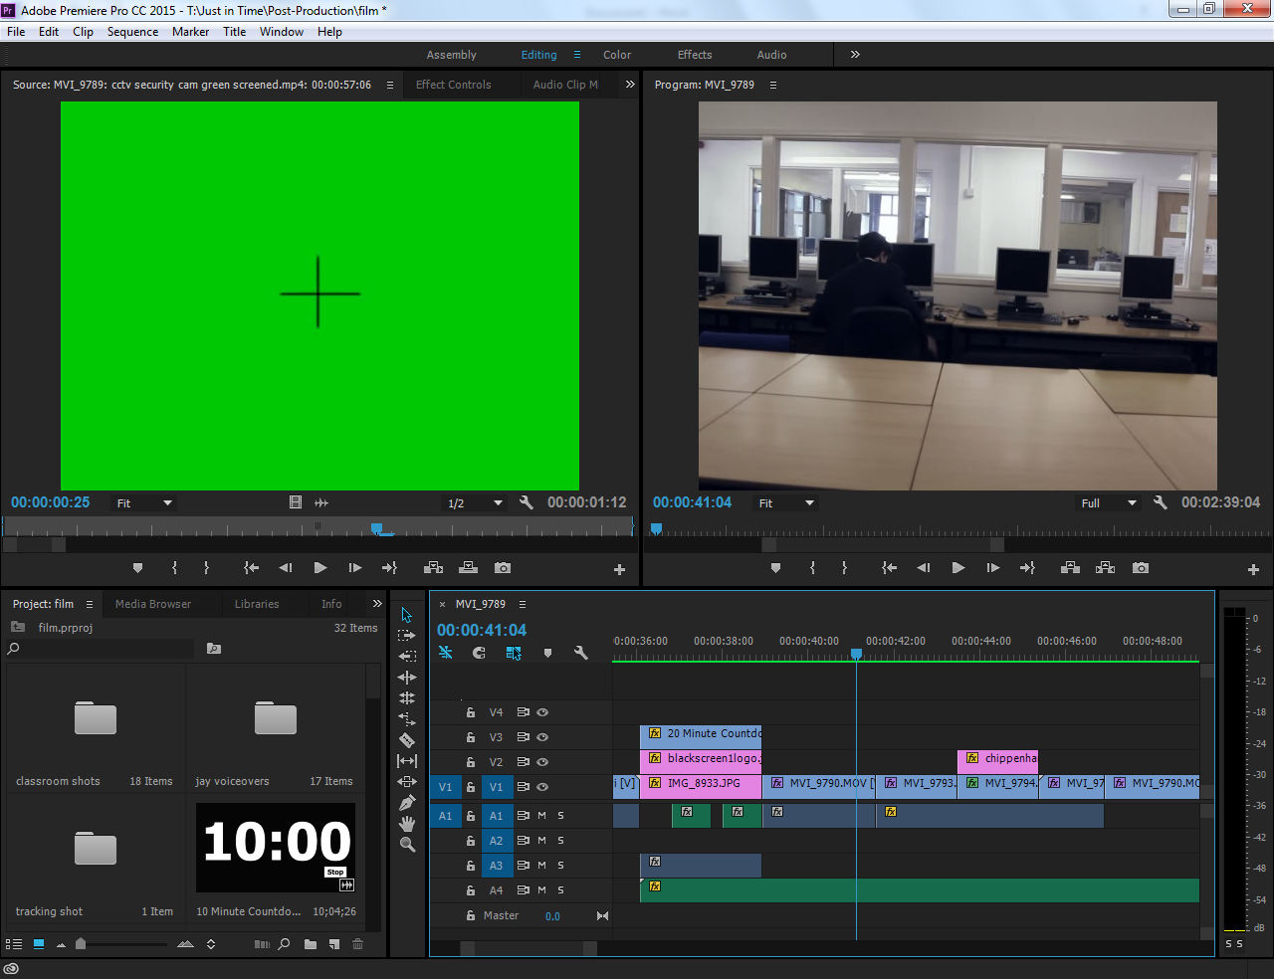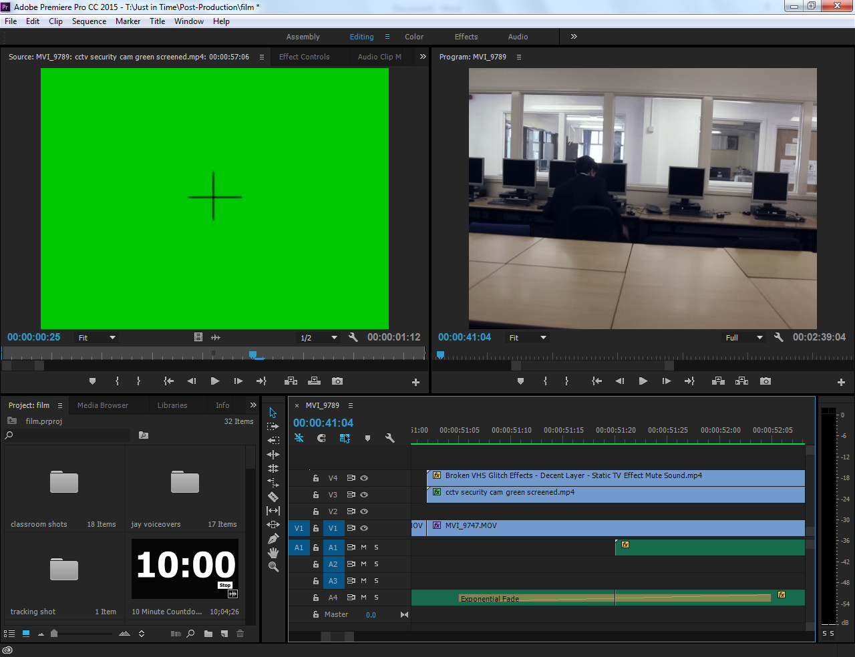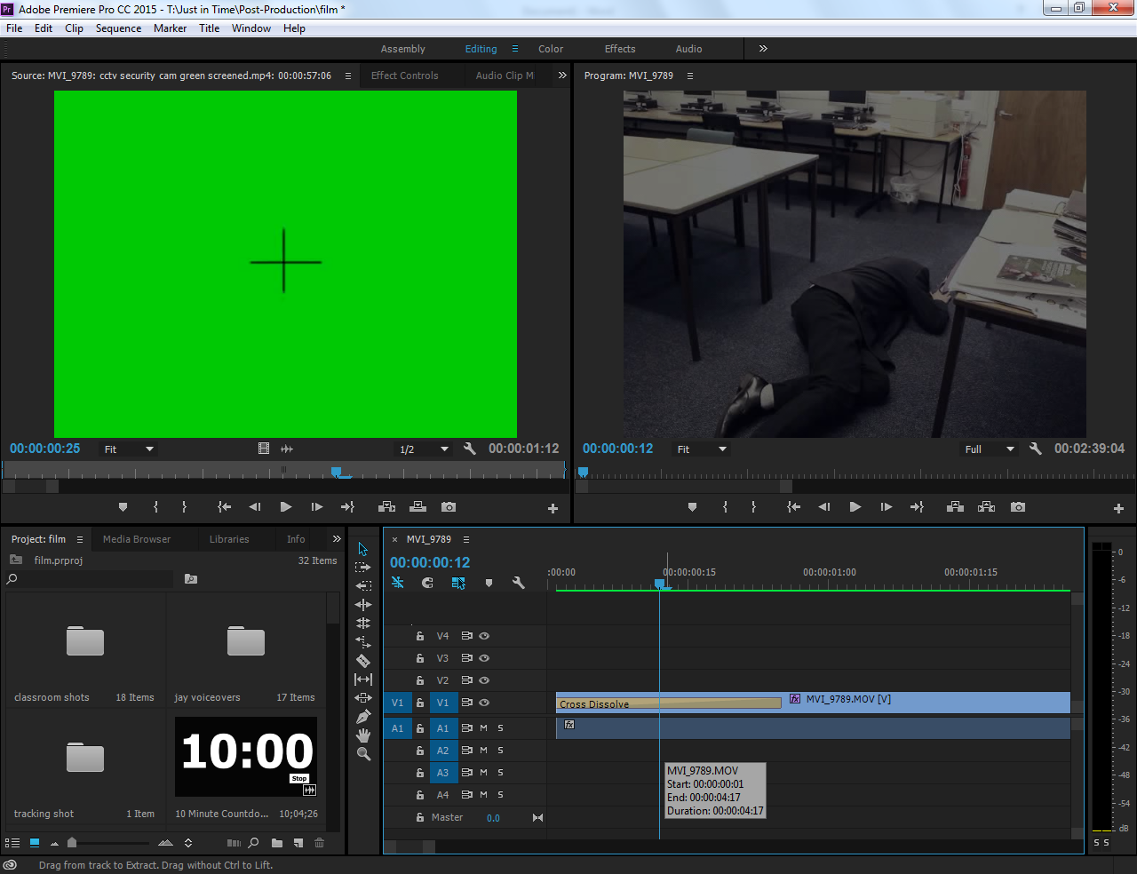

This is the security footage I edited. I used green screen footage of a security camera and colour keyed it to look real. I did the same with the tape effect that is over the top of it.

The green and blue parts are added in video footage such as a bomb timer or the footage of the dark figure. This was to improve my film and make it look more realistic.

The pink sections are where I’ve placed photos in my film, either where actual filming didn’t work or just added in extra footage.

I used an exponential fade here to quieten down the music whilst another piece of audio is playing, this is so that you can hear the playing audio clearer.

I put a cross dissolve on the beginning of my video so that when it starts, the first scene fades in, which gives it a good opening effect.